[KALASALINGAM ACADEMY OF RESEARCH AND EDUCATION]

SyllabusGPT – AI-Powered Document Question Answering System

Project ID: PRJ042
Team ID: T042
Team GitHub Repository: https://github.com/sweetysaroj83-svg/SyllabusGPT

Student Name | Registration Number | Individual GitHub Link
Y Hema ruthi | REG99230040070 | https://github.com/sruthireddyyanamala-jpg/Gen-ai-task
D Vasantha Lakshmi | REG99230040288 | https://github.com/vasantha2006/Gen-ai-tasks.git
Y Saroj Sweety | REG99230040827 | https://github.com/sweetysaroj83-svg/Gen-AI-Tasks
PC Pallavi | REG99230040053 | https://github.com/arehman1711/online-course
T Manasa Durga | REG99230040433 | https://github.com/Manasa914/GenAI-Tasks

Project Trainer / Guide
Mr. SHIRWIN PRINCE I

Table of Contents

- Introduction Section 1

- Problem Statement & Objectives Section 2
- System Architecture (RAG Pipeline) Section 3

- Implementation Details & Tech Stack Section 4
- Results and Testing Section 5

- Conclusion & Future Scope Section 6

Introduction

In today's digital learning environment, students frequently rely on textbooks, lecture notes, academic materials, and PDF documents to understand complex subjects and prepare for examinations. However, manually searching through lengthy documents to find specific information can be time-consuming and challenging. To address this problem, SyllabusGPT – An AI-Powered Document Question-Answering System is developed to provide an intelligent and interactive platform for learning and information retrieval.
SyllabusGPT is a web-based application that allows users to upload educational documents, including PDF files and images, and ask questions related to their content. The system extracts textual information from uploaded documents using PDF text extraction techniques and Optical Character Recognition (OCR). It then identifies relevant information from the extracted content and uses a Large Language Model (LLM) through the Groq API to generate contextual answers based on the uploaded material.
The application follows a basic Retrieval-Augmented Generation (RAG)-inspired approach, combining document-based information retrieval with AI-powered response generation. Keyword-based retrieval is used to identify relevant document content, which is provided to the language model as context for answering user queries.
The application is developed using Python and Streamlit, providing a user-friendly and responsive interface that can be accessed through desktop and mobile devices. Technologies such as PyMuPDF, pypdf, Pillow, Tesseract OCR, and Groq API support document processing and intelligent answer generation.
The primary objective of SyllabusGPT is to simplify the learning process by enabling students to interact directly with their study materials, obtain relevant answers, and access information more efficiently. It aims to make academic document analysis faster, easier, and more accessible through the integration of artificial intelligence.

Problem Statement & Objectives

Problem: Students often depend on lengthy academic documents, textbooks, lecture notes, and PDF files for learning and examination preparation. Finding specific information from these documents manually requires considerable time and effort. Traditional document-reading methods do not provide an interactive way to ask questions and receive immediate answers based on the uploaded study material.
Additionally, scanned documents and image-based notes create difficulties because their content may not be directly searchable. Students may also face challenges in understanding complex topics and locating relevant information across large documents.
Therefore, there is a need for an intelligent and user-friendly system that can extract information from educational documents, identify relevant content, and generate meaningful answers to user queries.
SyllabusGPT addresses this problem by integrating document processing, Optical Character Recognition (OCR), keyword-based information retrieval, and Large Language Model (LLM) technology into a single web-based application.

Objectives:
The main objective of the SyllabusGPT project is to develop an AI-powered document question-answering application that simplifies the process of accessing and understanding educational materials.
The specific objectives are:
- Document Upload: To provide an interface that allows users to upload educational documents in PDF and image formats.
- Text Extraction: To extract textual information from PDF documents using PDF processing libraries.
- Optical Character Recognition: To extract readable text from scanned documents and images using OCR technology.
- Information Retrieval: To identify relevant information from the extracted document content using keyword-based retrieval techniques.
- AI-Powered Answer Generation: To integrate a Large Language Model through the Groq API to generate contextual answers based on the retrieved document content.
- User-Friendly Interface: To develop an interactive and responsive web application using Streamlit.
- Accessibility: To deploy the application on Streamlit Community Cloud so that users can access it through desktop and mobile devices.
- Efficient Learning: To reduce the time and effort required to search through lengthy academic documents and improve the accessibility of study materials.

System Architecture (RAG Pipeline)

SyllabusGPT follows a Retrieval-Augmented Generation (RAG) architecture that allows users to interact with their study materials. The system accepts PDF documents and images, extracts text using PyPDF and OCR, and retrieves relevant information based on user questions through keyword matching. The retrieved content is combined with the user's query and sent to the Groq LLM, which generates a relevant, context-based response. Finally, the generated answer is displayed through the SyllabusGPT user interface.

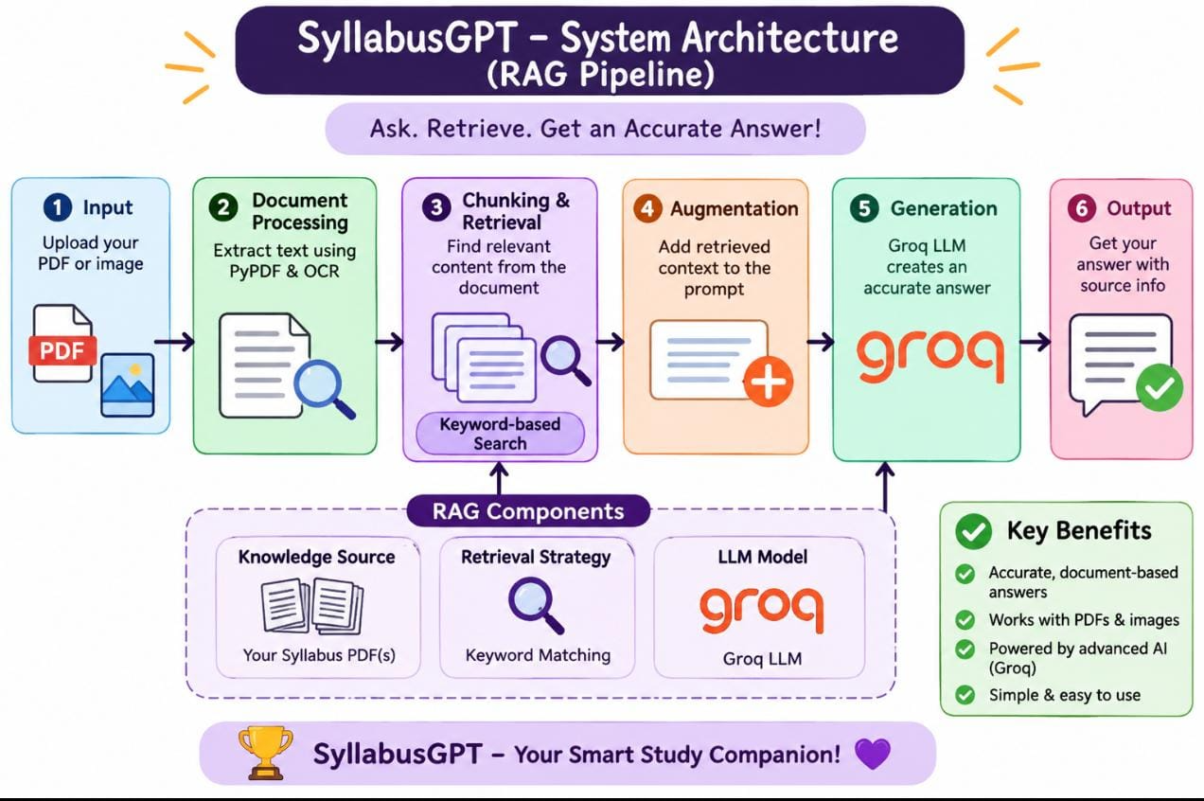
  - Data Ingestion Phase

The Data Ingestion Phase is the initial stage of the SyllabusGPT system, where users upload their study materials in the form of PDF documents and images. These uploaded files serve as the primary knowledge source for the application. The system accepts the documents and prepares them for further processing, including text extraction and information retrieval. This phase ensures that the required educational content is available for the RAG pipeline to generate relevant answers to students' questions.

  - Query & Generation Phase

The Query and Generation Phase is the final stage of the SyllabusGPT system, where users interact with the uploaded study materials by asking questions in natural language. When a user submits a query, the system searches the extracted document content using keyword-based matching to identify relevant information. The retrieved content is combined with the user's question to create a context-based prompt, which is then sent to the Groq-powered Large Language Model (LLM). The model processes the question and retrieved information to generate a relevant and understandable answer. Finally, the generated response is displayed on the SyllabusGPT interface, helping students quickly understand their study materials.

Implementation Details & Tech Stack

Component | Technology Used | Purpose
Programming Language | Python 3.10 | Core application logic and backend development
Frontend Framework | Streamlit | Creating an interactive and responsive web interface
PDF Processing | PyMuPDF (fitz) / PyPDF | Extracting text and content from PDF documents
OCR Technology | Tesseract OCR | Extracting text from scanned documents and images
AI Integration | Groq API | Connecting the application to cloud-based AI models
Large Language Model | Llama 3 / Groq-supported model | Generating contextual, human-like answers
Document Retrieval | Keyword-based Retrieval | Identifying relevant document content based on user queries
Image Processing | Pillow (PIL) | Processing uploaded images for text extraction
Configuration & Security | Streamlit Secrets | Securely storing the Groq API key
Cloud Deployment | Streamlit Community Cloud | Hosting the application and making it accessible online
Version Control | GitHub | Managing source code and project versions

Results and Testing

The SyllabusGPT application was successfully developed to help students understand their academic documents easily. Users can upload syllabus PDFs or images, extract text, and ask questions related to the uploaded content. The system uses keyword-based retrieval and the Groq API to generate clear, relevant, and understandable answers. It also provides unit-wise explanations, making learning easier and saving students' time.

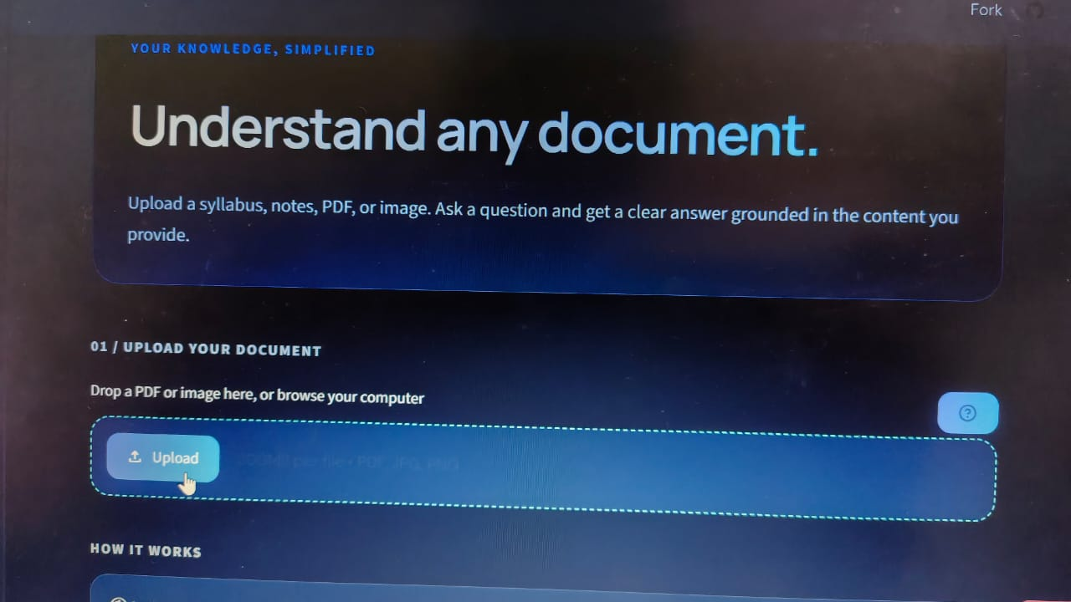
Fig:5:1

- SyllabusGPT is an AI-powered document understanding application designed to help students learn easily. It allows users to upload academic documents such as syllabus PDFs, notes, and images. Students can ask questions about the uploaded content and receive clear, relevant answers. The main aim of this project is to make learning easier, faster, and more interactive.

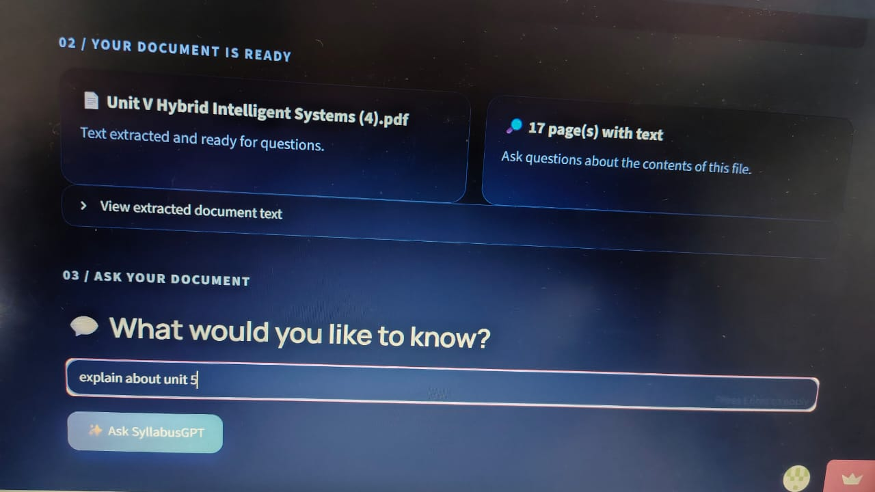
Fig:5:2

- In this step, the user uploads a syllabus PDF into the SyllabusGPT application. The system successfully processes the uploaded document and extracts text from all 17 pages. The extracted content is displayed and made ready for questions. Users can enter questions about specific topics or units and receive relevant AI-generated answers.

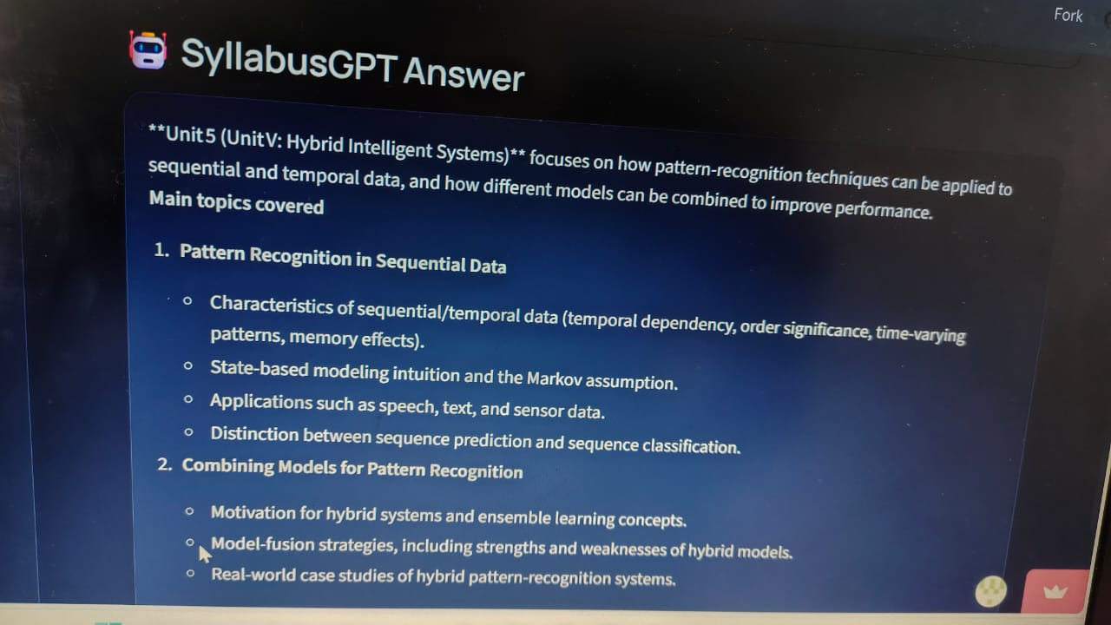
Fig:5:3

- In this final step, the SyllabusGPT application generates answers based on the questions asked by the user. For example, when the user asks to explain Unit 5, the system provides a detailed explanation of Hybrid Intelligent Systems. It identifies the main topics, important concepts, and applications in an organized format. This demonstrates that the application successfully understands document content and provides clear, relevant, and easy-to-understand answers using AI technology.

Conclusion & Future Scope

Conclusion: The SyllabusGPT project successfully provides an AI-powered solution for understanding academic documents. It allows users to upload PDFs and images, extract text, ask questions, and receive clear, relevant answers. By integrating keyword-based retrieval and the Groq API with an LLM, the system makes learning easier, faster, and more interactive. Overall, this project helps students understand complex topics, saves time, and improves the learning experience.
Future Scope: The SyllabusGPT project can be further improved by adding advanced features to make learning more effective and interactive.
1. Multi-Language Support: Provide answers in different languages for better understanding.
2. Voice-Based Interaction: Allow students to ask questions using voice commands and receive spoken answers.
3. AI-Based Summarization: Generate short summaries of lengthy PDF documents.
4. Multiple Document Support: Allow users to upload and process multiple PDFs at the same time.
5. Chat History: Save previous questions and answers for future reference.
6. Mobile Application: Develop a mobile app so students can access the system anytime and anywhere.
Overall: In the future, SyllabusGPT can be developed into a complete AI-powered learning assistant that helps students understand subjects, prepare for examinations, and improve their learning experience.

